**Classifying Electrical Impedance Tomography**

**images by resistances based on contours**

**Sudhanva Narayana**

Machine Learning Engineer, Faststream Technologies

Bengaluru, Karnataka, India

[*nsudhanva@gmail.com*](mailto:nsudhanva@gmail.com)

**Vinod Agrawal**

Chief Technology Officer, Faststream Technologies

Bengaluru, Karnataka, India

[*vinod.agrawal@faststreamtech.com*](mailto:vinod.agrawal@faststreamtech.com)

**Abstract:** This paper will be of interest for Health Care Data Analysts, Data Scientists, Doctors and Medical researchers. This report provides an overview of current practice of Electrical Impedance Tomography (EIT), its imaging and use-cases. Electrical Impedance Tomography is a non-invasive type of medical imaging. These advances are improving our capacity to treat and even prevent cancers. The full implications of the subject remain to be explored. Examples of research techniques used in this project are detailed.

**1. Introduction**

Human bodies have electrical properties, specifically the electric conductivity and permittivity. The electric conductivity is a measure of the ease with which a material conducts electricity; the electric permittivity is a measure of how readily the charges within a material separate under an imposed electric field. Highly conductive materials allow both AC and DC currents to pass through them. Highly permissive materials allow only AC current to pass through them. Both of these properties can be used in medical applications as tumours, tissues and other irregularities in human body have different conductive and permissive properties. Other application of EIT include detection of blood clots, pulmonary emboli and gas in human body. Electrical Impedance Tomography – images are typically colour based representing the resistive properties on human bodies. The following image (right) is an experimental EIT image generated using electrodes

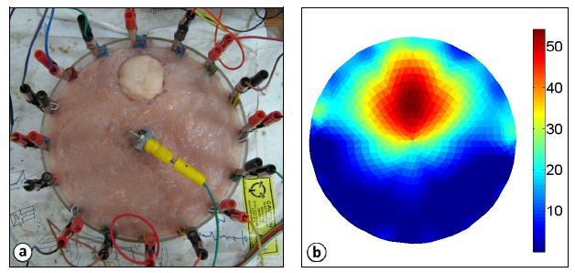

The resistive properties of the images are assigned colour codes and are plotted.

**2. Machine Learning**

Machine Learning is the science (and art) of programming computers so they can learn from data. For example, your spam filter is a Machine Learning program that can learn to flag spam given examples of spam emails (e.g., flagged by users) and examples of regular (non-spam) emails. The examples that the system uses to learn are called the training set. Each training example is called a training instance (or sample). In this case, the task T is to flag spam for new emails, the experience E is the training data, and the performance measure P needs to be defined; for example, you can use the ratio of correctly classified emails. This particular performance measure is called accuracy and it is often used in classification tasks.

*Supervised Learning*

Machine Learning systems can be classified according to the amount and type of supervision they get during training. There are four major categories: supervised learning, unsupervised learning, semi-supervised learning, and Reinforcement Learning. In supervised learning, the training data you feed to the algorithm includes the desired solutions, called labels. A typical supervised learning task is classification. The spam filter is a good example of this: it is trained with many example emails along with their class (spam or ham), and it must learn how to classify new emails.

**3. Proposed Methodologies**

The goal of the project is to validate performance of Electrical Impedance Tomography’s performance across various Machine Learning – Classification algorithms. Image is read into code in the form of a three-dimensional matrix where in each dimension represents intensities of the respective colour code. This three-dimensional matrix is then converted to two-dimensional matrix (representation of grayscale image) with intensities ranging from 0 to 1. Image is re generated to observe distribution using contour plots. A. Based on the data obtained and observation from the graphs, random multidimensional matrices are generated. Using radial basis function on these matrices, values ranging from 0 to 1 are created. 1000 random-related

images are created based on the matrices and its values. The generated images are read back into code and are plotted to observe the distribution of intensities. Mean intensity ranges are calculated and are assigned labels (colours) correspondingly. The generated images are parsed and respective intensity ranges, its count of pixels and percentages are calculated. A dataset of 8 intensity ranges (columns) and 1000 values (rows) are created. Mean of pixel count of all ranges are taken in consideration and is used as a criterion for assigning targets. Binary targets are generated and are appended to the existing dataset as a target column.

The project works across any images in general but is concentrated on images generated by contours and sine, cosine functions. A sample EIT Image is read into the code in the form of a 2-dimensional matrix. This matrix represents intensities of various colour gamut. The project revolves around generating images and reading those images into matrices. A dataset of count of pixels of various intensity ranges are created. A machine learning model is created out the dataset.

List of classifiers/algorithms used:

* K – Nearest Neighbours
* Decision Tree Classifier
* Kernel Support Vector Machines
* Logistic Regression Classifier
* Naïve Bayes Classifier
* Random Forest Classifier
* Support Vector Machines

**4. Identifying pixels by contours**

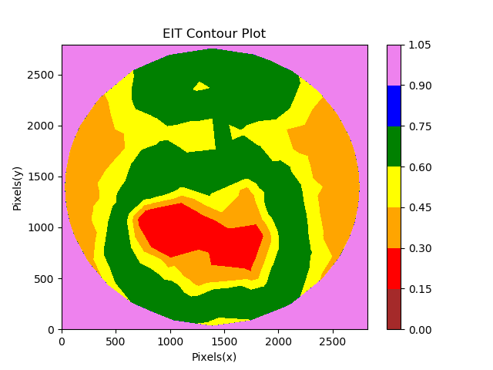 A typical contour image of the same EIT Image looks like this. The colours here are representative and are not related to any colours in resistive properties. The intensity range is from 0 to 1 where 0 being the lowest and 1 being the highest. The x and the y axis are count of pixels